Chapter 8, Problem 17.

In the circuit of Fig. 8.71, the switch moves (a make before break switch) from position A to B at t = 0. Find v(t) for all t ≥ 0.

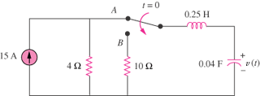
5 A

Figure 8.71
For Prob. 8.17.

